

glow os

The operating system designed to redefine the use of your devices, enabling them to be the best and most important things you own, designed to deliver on the promise that other operating systems had promised….. the Operating System of the future… by Grape Technologies™

the OS of the future

glow os

the OS of the future

grape technologies

The little band of people dedicated to making the future a brighter better place.

Join us and help us make a tasty future…

www.thegrapetechnologiesforum.wordpress.com

Since the 1990’s the search for the perfect Operating System has been there and the Operating System has been responsible for redefining a computer’s purpose….though not to the best…. Glow OS intends to change this….focusing on the device of the decade….The smartphone….we intend to redefine the purpose of the smartphone back into the true PDA…..Personal Digital Assistant…. By going back to the original purpose of these devices and reintroducing it’s essentials...incorporating the modern purpose with the intent of making a beautiful future….

It was brought to life…this concept, back in the year 2008….and since then, it’s faced a lot of changes….but the original philosophy of efficiency and productivity remain the same.. and become still the driving force and purpose of the operating system.

the integrated OS.

This OS is designed to be integrated into all Grape Technologies devices and is meant to be versatile to accommodate smartphones, laptops, TVs, Smart Fridges, and even smartwatches..making them easier to pair into each other causing a unified user experience….if such a case is possible, a unique connection can be found..to further enchance their ecosystem….. maybe solve IoT challenges…it allows us to make new file types enhancing productivity and the longevity of the use of the software we provide…

Being in the African market doesn’t bring a challenge, rather , an opportunity is formed that can be crucial for our combined growth…

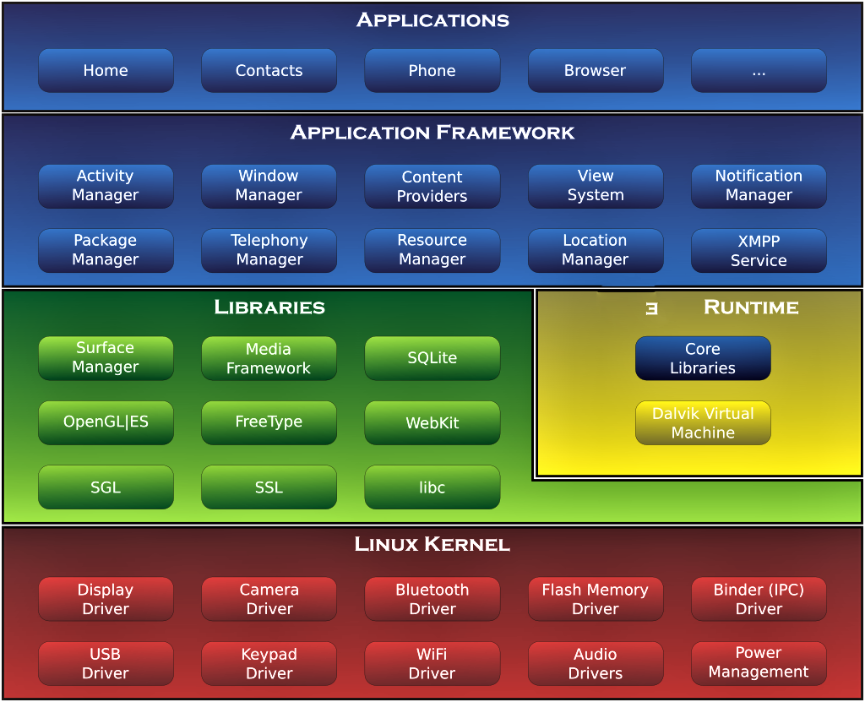

THE SYSTEM ARCHITECTURE.

The system architecture of this Operating System is drawn of from the original Android system

structure, however, since this document is proof of the Operating System concept, this is the

best architecture to adopt...since a linux kernel is open sourced and free for use.... the ideal

architecture is an incorparation of the now dead FirefoxOS and this architecture.... compatability

will be measured by the availability of an already existing SDK....which rights to can easily be

gotten at little to no cost and to which modifications can be made to adapt to Operating System

Goals...

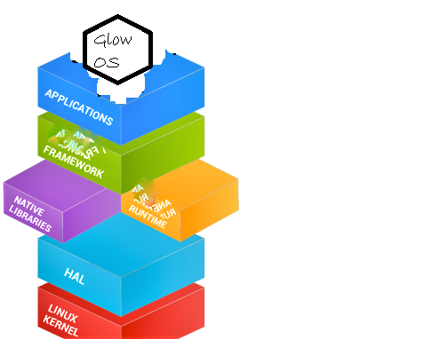

THE SYSTEM LADDER

GlowOS ladder is bound on the same ladder as the famous android system as it has been a

successful forerunner. drawing from the same structure brings forth better security internally

and a stronger intergrity externally as we design them for diffrent devices and computers

of diffrent form factors

# matters concerning popular compatability

The Operating system may encounter a question of popular compatability, meaning the concept of a popular strategy to keep the Operating System in use due to an abundance of applications usable on the system to which case, if the Operating System has not yet developed a usable open source SDK for applications to be applied effectively into the Operating System , or, even in the process of such a development stage of the Operating System, must be suggested, use of an Android Runtime since the Operating System is based on a Linux Kernel. This Runtime should be able to support Android Applications supporting all known versions… to such a capacity, an app store which will contain Homebrewed applications should be made.

THE USER INTERFACE OF THE OS

The User Interface of this Operating System…..in it’s concept stage, has gone through very significant changes, but , through the changes, the focus has been on a smoother, more natural, less noisy UI which will allow the user to not only enjoy using the devices, but also help the user to focus on the things that matter, emphasizing on the use of the phone, texting, e-mailing, and messaging services, and providing priority to applications enchancing the use of the phone’s capabilities, the camera, the music player, the browser and other applicatons of the sort.

A touchy issue is the use of a homescreen.. which is supposed to be the user’s free page, we have redesigned that screen to allow you to do more than just save your most recent apps, and employ your favorite widgets, it allows you to employ more actions, put on more wallpapers, and employ more themes.

To separate, business life from personal life, we have employed, lightly, but effectively the use of user profiles, and it gone way past unique ringtones and sound settings and gone all the way into themes, duplicate apps, different homescreens and profile priorities… this, will revolutionize the way people will use their devices, both as entertainment and productivity devices, not forgetting Philosophy which is the prioritization of the modern phone devices as Personal Digital Assistants the Operating System.

